- Install R 4.5.1, while installing, check to create shortcut on desktop
- Download MiKTeX and install it
- Download pandoc 3.1.3 and install it
- Right click on R (x64) icon on desktop, and “run as administrator”, and run these commands:
Install.packages(“rmarkdown”)
Install.packages(“openxlsx”)
- Restart computer as instructed by pandoc
- Download the pipeline files, and configure
- When running for the first time, the program may ask to install some .sty file needed by TeX. Install the needed files.
- Go to Windows, search for MiKTex console
  - In updates, click check for updates
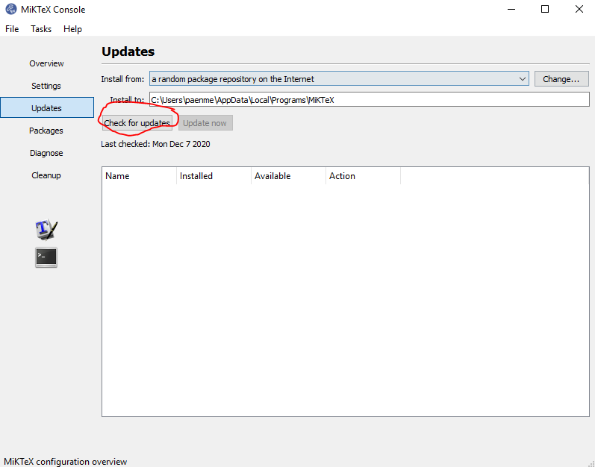
When the packages are loaded, click “update now”
  - In settings, check “always install missing packages on-the-fly”
